DETERMINING CALIBRATION CURVES
Using Microsoft Excel

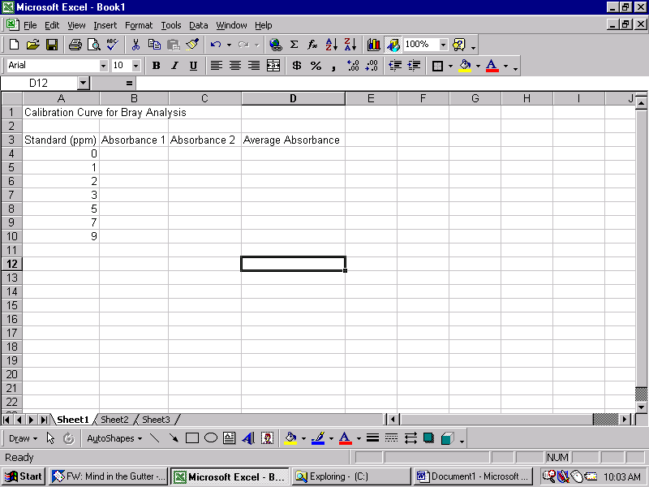
- Set up spreadsheet with a column for the known concentration of the standards and a column for the absorbance values from the spectrophotometer.

- Input absorbance values for each standard. If standards were measured more than once, create a second column and input the second set of numbers.

- If the absorbance of each standard was measured multiple times, create an average absorbance column.
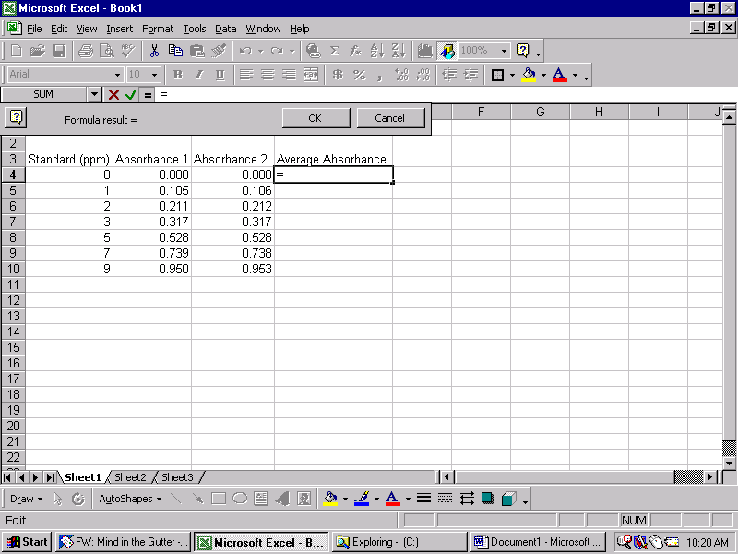
  - To average numbers in Excel, click in the cell that you would like excel to put the average number then click on the equals sign above the worksheet (or simply hit the equals key).
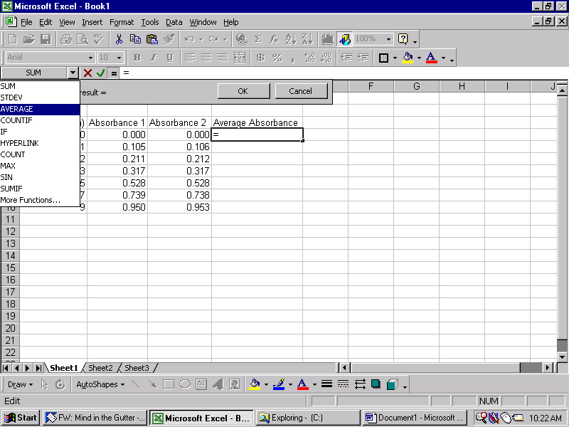
  - If AVERAGE is not bold and highlighted to the left of where you clicked, you need to change the function excel is going to do by clicking on the down-arrow. This accesses a pull-down menu with the common functions in Excel. Select AVERAGE from the pull-down menu.

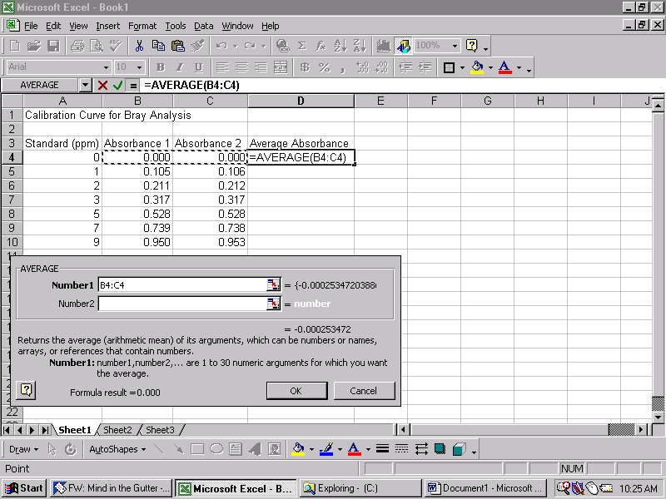
  - Once AVERAGE is selected a window will pop up asking you to select the cells you want Excel to average. Simply click and drag the mouse across the cells you want averaged then click on OK. You may need to move the window out of the way to allow you to select the cells.

- Once you click OK, the window will close and the average of the cells you selected will be displayed. In some cases you may want Excel to provide you with averages for several numbers in a list, click on the cell with the average you just made.
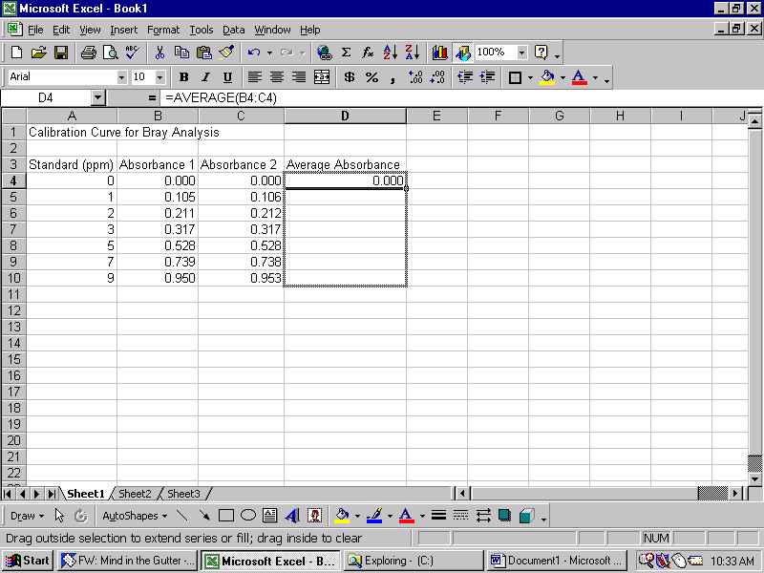
  - Move the pointer to the lower right-hand corner of the cell (cursor will turn to a solid plus-sign). Click and drag the box down until it surrounds all of the cells you want an average in.

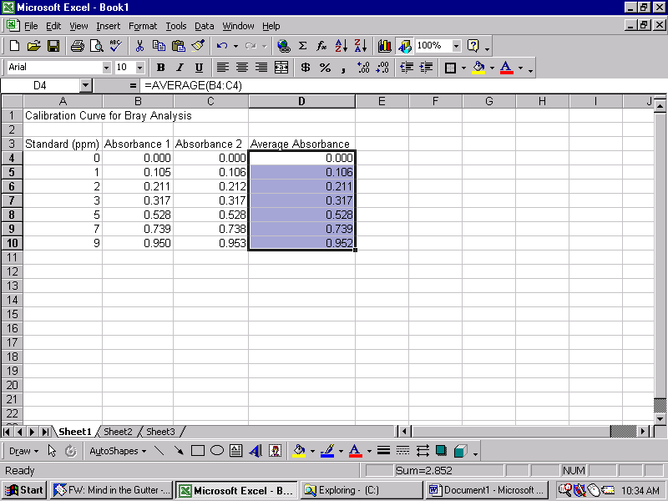
  - Once you release the button on the mouse averages will appear for each of the cells. Doing this click and drag on any cell in Excel is a way of copying and pasting the value or formula in the original cell to any number of new cells.

- Once you have obtained averages for all of your absorbance values you are ready to use Excel to create a graph.
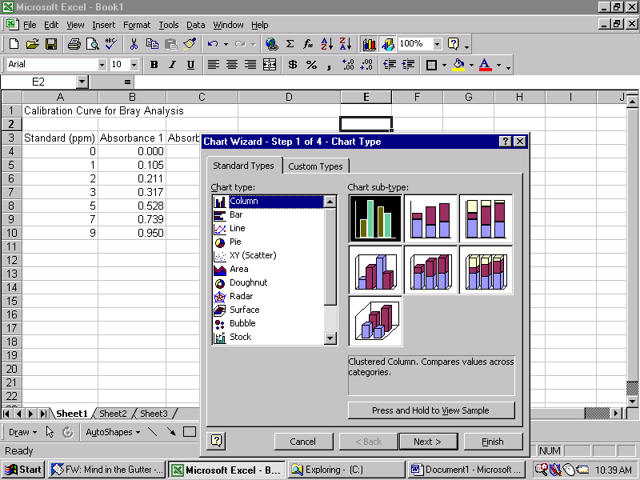
  - Click on the graph button above the worksheet or use the pull-down menu to select Chart under the Insert menu at the very top of Excel. When you do this Chart Wizard will appear (its magic).

  - Select XY (Scatter) from the Chart type: screen and accept the default by clicking “Next >” at the bottom of the window.
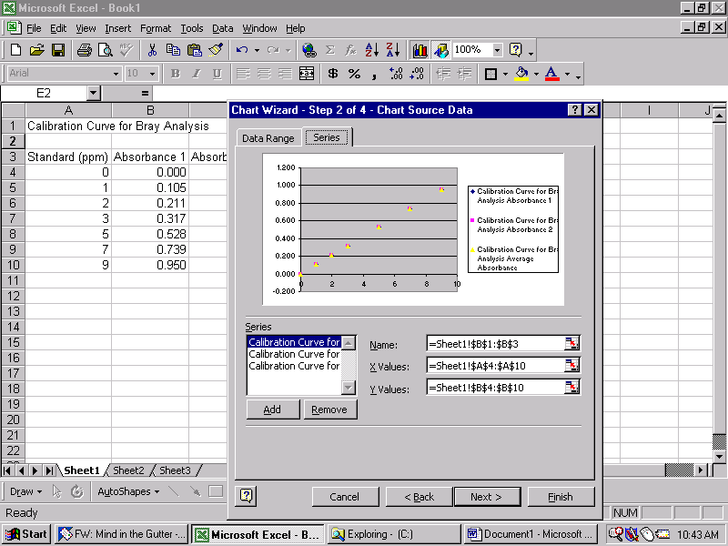
  - By default Excel will try to make a graph with the data in your current spreadsheet. You can see a preview of this graph in the widow. We do not want to use the default, so click on the Series tab at the top of the preview window.

  - If Excel has automatically created scatter plots for you, click on the Remove button until they are erased.
  - Once all of the scatter plots are erased, click on the Add button.
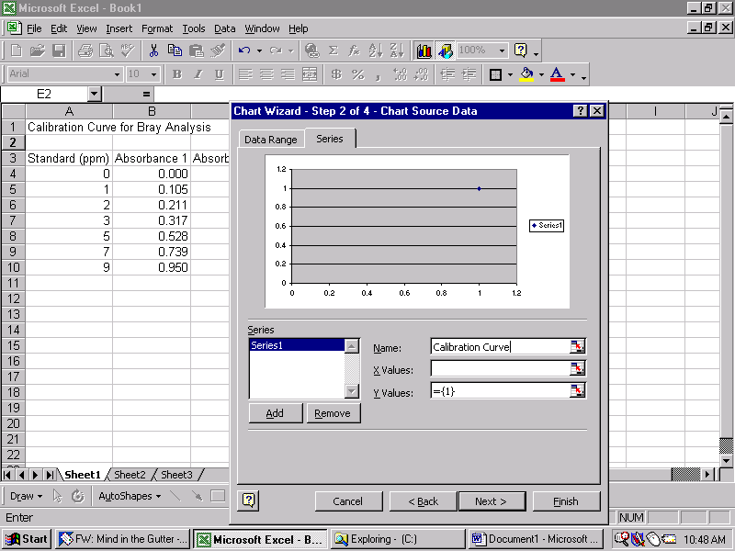
  - Now we can name our graph. Click in the Name line and type “Calibration Curve” (or whatever you would like to call it).
Click here to select your X values
  - Next, click on the button to the far right of the X Values row (this allows you to highlight the cells that Excel will use for the X in your scatter plot.
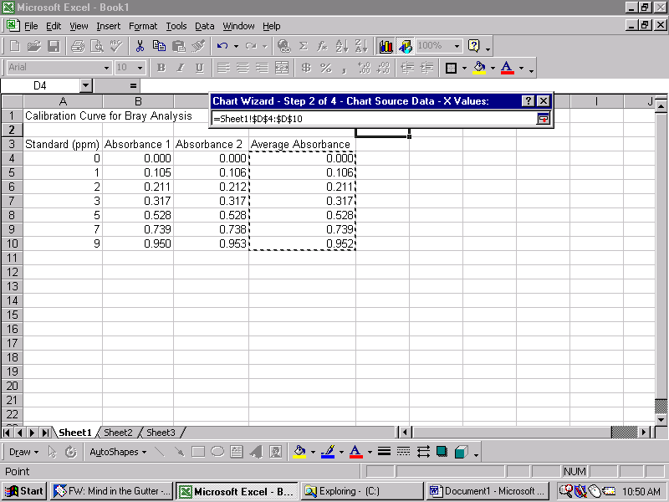
  - Use the mouse to highlight the numbers in the Absorbance or in this case Average Absorbance column in your sheet. Once you have these values highlighted, click on the button to the right of the task window that popped up.
Click here once you have highlighted your data

  - Repeat the above step for your Y values but use the standard concentrations. Once you have these selected click “Next >”

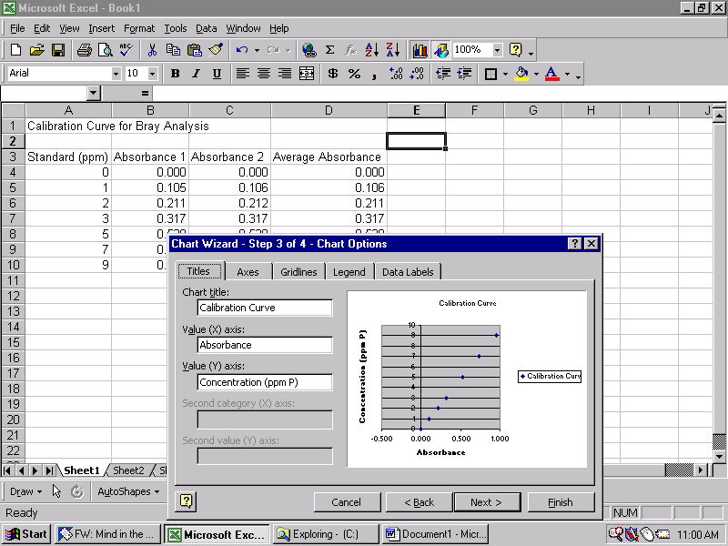
  - After clicking next, the chart wizard will ask you to provide it with labels for your X and Y-axes. Label the X-axis Absorbance and the Y-axis Concentration (ppm P).

  - Once you have correctly labeled your axes, click next. Excel will ask you if you want the graph to be placed in the current Sheet (default) or if you want it put into a new sheet. You want Excel to put the graph into the current sheet so click Finish.
- Now you have a graph of your standard Concentration vs. Absorbance. You can move the graph around your worksheet as well as resize it by selecting it and clicking on the corners of the graph. To use this graph for our samples you need to have the equation for the regression line from your standard data. The regression equation is a linear equation that relates X (absorbance) to Y (concentration) so that you can calculate the concentration of your sample from its absorbance.
  - To obtain the regression equation, click on the graph in your sheet.
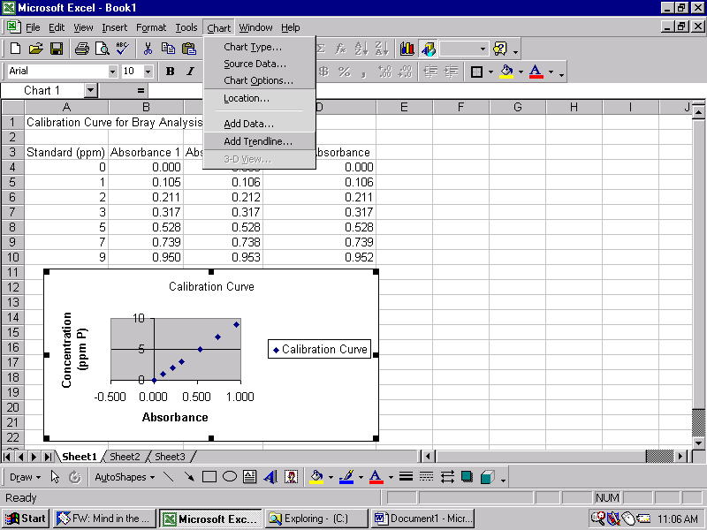
  - Use the Chart pull-down menu at the top of Excel to select the “Add trendline” option.

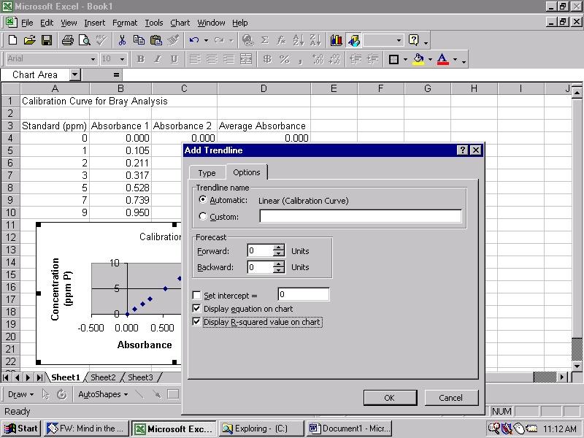
  - Once you click on Add Trendline, a window will pop up asking you about the type of trendline you would like to use. We want to use a linear regression (default). Before clicking OK we need to select a couple of options, so click on the Options tab.

  - Once you click on the Options tab, be sure that you check the boxes labeled “Display equation…” and “Display R-squared…” Then click OK.
  - After clicking OK, you will see that Excel has drawn a trendline on your graph and displayed both the equation and r² value.
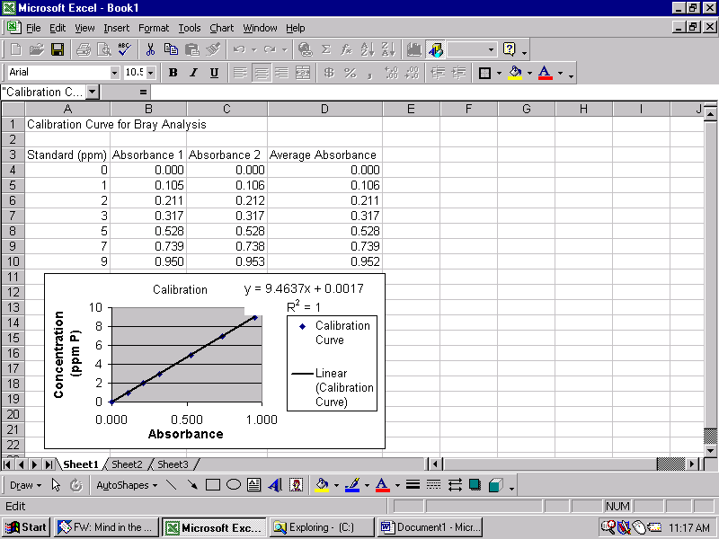
- Now we are ready to use our calibration curve to calculate the concentrations of our samples. To do this, we will need to input the calibration equation into excel so that it calculates the concentration for us
  - Input your data, making two columns (Absorbance and Concentration). This can be done below or beside what you have already done in your sheet.
  - Once you have your data put into the sheet. Click in the cell under the Concentration column and click on the equals sign above the sheet next to the “Formula Bar”.
  - Input the regression equation manually into the “Formula Bar”. If your regression equation is:
y = 9.4637x + 0.0017
Then you input the following into the “Formula Bar”, then hit Enter:
=9.4637*G4+0.0017
G4 is the cell containing the corresponding absorbance value for the sample.
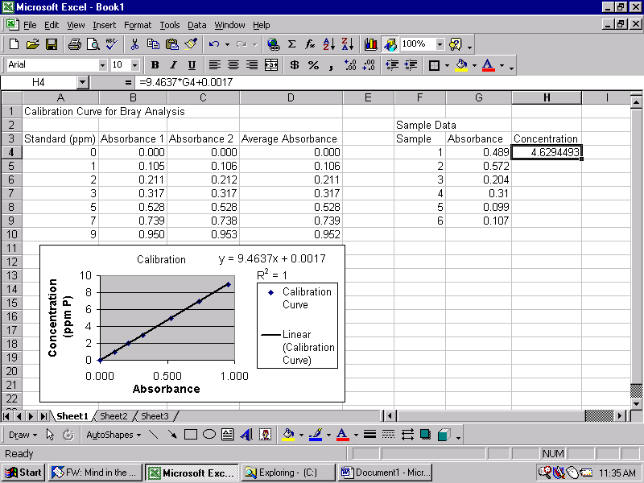
  - Once you have input the regression equation. Click on the cell and highlight all of the cells next to the absorbance values for your samples to copy the formula (same process as mentioned above in 4 a & b).
- These steps can be modified and repeated to accomplish numerous calculations.
- To print what you have entered into your spreadsheet, use the mouse to highlight the cells you are interested in.
- Once you have the cells highlighted, click on the “File” menu, go down to “Print Area” and then “Set Print Area.”
- Now when you print, only what you highlighted will be printed.
- To print only a graph, click on the graph and then click print, it should automatically format what you are printing so that it fits on one piece of paper.

