SOIL 4234 Laboratory #10
Soil Test for P, K, Mg, and Ca (10 points)

Student
Lab
TA

Objectives

- To gain experience with colorimetric analysis, a common analytical technique used to measure the concentration of ions in solution.
- To develop an understanding of standard preparation and the use of a standard curve.
- To gain experience and understanding of the phosphorus soil testing procedures used in Oklahoma.

Introduction
Phosphorus in soil exists in many forms and concentrations can range from 200 – 5000 mg total P kg⁻¹ soil. Of this total P, only a fraction is present as soluble H₂PO₄⁻ or HPO₄⁻² (forms taken up by plants). Even in fertile soils, solution P concentrations rarely exceed 0.2 mg P L⁻¹. You have already learned that most soils have a net negative charge and tend to repel anions. If this is so, then why are phosphate ions held so strongly by soils? The answer lies in the multiple reactions P undergoes both at the surface of soil particles and in the soil solution. Iron and aluminum hydroxides can be present in the soil as coatings on soil particles or as amorphous (non-crystalline) precipitates. Anions like NO₃⁻ and Cl⁻ undergo non-specific adsorption at the surface of hydrated oxide minerals, while H₂PO₄⁻ undergoes specific adsorption by ligand exchange. Non-specifically adsorbed anions diffuse into the soil solution much more easily than specifically adsorbed anions, thus they are more available to plants and are subject to greater losses via leaching or surface runoff. A diagram representing non-specific and specific adsorption is shown below.

Hydrated iron
oxide mineral
Non-specific adsorbtion
Specific adsorption
(ligand exchange)
H
2
PO
4
-
NO
3
-
Cl-
Fe
OH
2
OH
2
Fe
O
O
OH
-
P
O
OH
OH
Fe
OH
2
Fe
O
Fe
O
H
2
H
2

O
Fe
O
Cl
NO
3
O
P
O
OH
O
Fe
Fe
O
OH-
Hydrated iron
oxide mineral
Fe
OH
2
OH
2
Fe
O
Soluble Fe, Al, and Ca ions can also precipitate with soluble P compounds or form soluble complexes with soluble H₂PO₄⁻, HPO₄⁻², and other P-containing ions that are not available to plants. The formation of these complexes and precipitates is highly dependent on the pH and redox status of the soil. The figure below shows how pH can affect the formations of P-containing complexes in solution (From Lindsay, 1979).

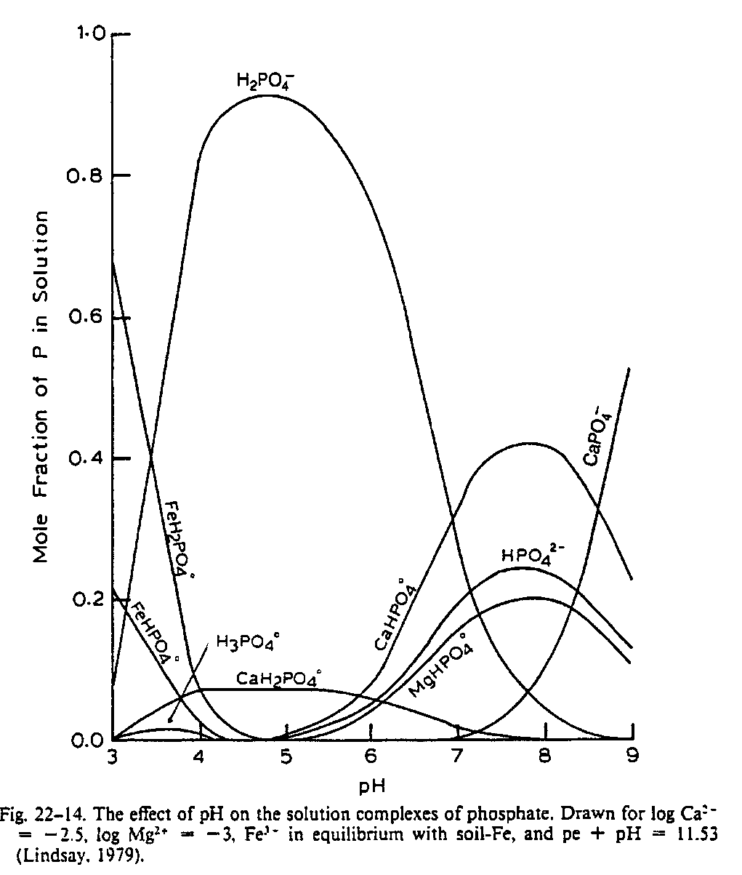
In acidic, highly weathered soils, inorganic P exists mainly as Al- and Fe-phosphates. In more alkaline soils, Ca-phosphates will dominate. Phosphorus also exists in natural organic material including plant and animal tissues, manures, and humus. Many organic phosphorus compounds have been characterized in soils, including inositol phosphates, phospholipids, nucleic acids (DNA and RNA), and polyphosphates.
Most soil tests do not measure all of the P available to plants. However, the amount of P extracted is correlated to plant P concentration, plant growth, and the plant response to P added in fertilizers or manures. A number of different extracting solutions have been developed as P soil tests. Each one has particular advantages and disadvantages, depending on the characteristics of the soil and the dominant form of P present. These extractants are commonly grouped into four categories:
1. Dilute solutions of strong acids such as H2SO4, HCl and HNO3 which are effective in extracting Ca-P, Fe-P and Al-P in acid and neutral soils (Mehlichs double acid).

2. Dilute solutions of strong acids plus a complexing ion such as NH4F, which are most effective in acid and neutral soils (Bray P1, Mehlich 3).

3. Dilute concentrations of weak acids such as citric or acetic acid which are effective in extracting Ca-P and will also complex the Al ion facilitating the extraction of Al-P (Lancaster's Extractant).

4. Buffered Alkaline Solutions such as NaHCO3 which have been most effective in predicting available P on calcareous soils high in Ca-P (Olsen's).

Which extractant to use is normally dependent on the forms of P present in soils and other soil properties such as soil texture and soil pH.
In Oklahoma, the Mehlich 3 extractant is the standard extractant used. The phosphorus fertilizer recommendations made by Oklahoma State University are based on the Mehlich 3 test. This extractant is a solution of 0.2 N CH₃COOH (acetic acid), 0.25 N NH₄NO₃ (ammonium nitrate), 0.015 N NH₄F (ammonium fluoride), 0.013 N HNO₃ (nitric acid), 0.001 M EDTA [(HOOCH₂)₂NCH₂NCCH₂COOH)₂, ethylenediaminetetraacetic acid]. The acids increase the solubility of the complexed Fe, Ca, and Mg – PO₄ and PO₄ in solution. The F⁻ has a high affinity for alumuninum and complexes the Al₃⁺ released by the acids and prevents AlPO₄ formation.
In the high pH, calcarious soils (>7.5) of the western Great Plains, the acid extractants become less effective. These soils contain free calcium carbonate which neutralizes the acid and prevents the extraction of P into solution. Two approaches are commonly used to solve the problem. One is to increase the amount of extractant to compensate for the neutralization problem. The other is to use an alternate extractant. Olsen's extractant is a buffered sodium bicarbonate solution which is alkaline and designed for use on calcareous soils. This extractant is excellent at extracting calcium-P, the dominant form of P in calcareous soils.
Factors other than the choice of extractant can also influence the amount of P which will be extracted from a soil by a soil test. How long the extractant reacts with the soil is very important. The longer a soil and extractant are shaken together in an extraction procedure, the more of the nutrient that generally will be removed. Changing or not controlling shaking time are two important sources of lab variation. One of the most common causes of a laboratory not meeting certification standards is uncontrolled shaking time. Mechanical timers which automatically shut down the shaker at a specified time are an important part of the soil testing process.
The amount of extractant used in a test is also important. Generally as one increases the amount of an extractant used in the test, the amount of P obtained will increase. Increasing the amount of Mehlich 3 extractant to compensate for a problem such as neutralization of the weak acid in calcareous soils is commonly done. But one would need to know of this change in soil:solution ratio when trying to interpret the results obtained. Generally this would also require that this "new" procedure be correlated and calibrated separately to allow making quality fertilizer recommendations.

Procedures

- Mehlich-3 Extraction

1. Obtain and label two 125 mL Erlenmeyer flasks.

2. Weigh 2.0 grams of soil and put it in each of the labeled flasks.

3. Add 20.0 mL of Mehlich 3 extracting solution to each of the samples in the flasks.

4. Place the 125 mL flasks with your soil samples and extractant onto a shaking rack and shake for five minutes.

5. Pour the soil-solution mixture from the flasks into a filter funnel, saving the filtrate in a clean 125 mL Erlenmeyer flask. Note: You only need 3 mls of filtrate. Refilter if filtrate is not clear!

- Preparation of Standards for Mehlich 3 (see curves in the slide set)
 | K (ppm) | P (ppm)
High | 100 | 50
Medium | 10 | 10
Medium low | 4 | 2
Low | 1 | 0.5
Blank | 0 | 0

- Determine P concentration of your sample from the standard curve.

- Calculations

- mg P/ kg of soil

- lbs P / acre = ppm x 2

***Note: ppm = mg/L or µg/mL or mg/kg or µg/g

Report (15 pts. total)

Data Sheet (6 pts.)

Data Table
K intensity = 135,000
P intensity = 185,000
_______________
Weight of Sample | 2 g
Volume of MEHLICH 3 Solution | 20 ml
Concentration in Soil (mg kg⁻¹) P

Concentration in Soil (mg kg⁻¹) K

Questions

- (2 pts.) Why do the acid extractants become less effective in high (alkaline) pH soils? Describe two approaches that are commonly used to solve this problem.

- (2 pts.) Assume a soil testing lab accidentally used twice the amount of the extracting solution described by their standard method (i.e. 40 mL of Mehlich 3 extranct vs. 20 mL):

  - How would this influence the analysis?

  - How would this influence the interpretation (P fertilizer recommendations) for a turf or crop manager?

- (2.5 pts) [THINK ABOUT IT] Looking at the CEC lab (from earlier in the semester), what does this lab have to do with the CEC lab. What parts of this lab did we utilize? How did they affect CEC?

4. For Corn given the suffiency curves for P & K in the powerpoint, would there be any application of P &/or K necessary? If so what is your application rate recommendation?

Conclusion (2.5 pts.) How does it apply to your field of study or will be applicable in your future career?

